**Volunteer Coordinator**

|  |  |
| --- | --- |
| **Role outline** | |
| **Salary:** | £29,000 per annum, pro rata for 0.4 FTE |
| **Contract:** | 12 months fixed-term contract |
| **Hours:** | 15 hours per week. Days and hours to be aggreed. |
| **Location and Travel** | Our office is based in Watford though all our team works flexibly with some hours from home. |

**ABOUT GOODS FOR GOOD**

Goods For Good was established in 2014 by founder Rosalind Bluestone. Driven by the desire to reduce waste and provide essential aid to vulnerable communities globally, Goods For Good aims to bridge the gap between excess and need, ensuring that unsold goods are used to improve the lives of those in crisis.

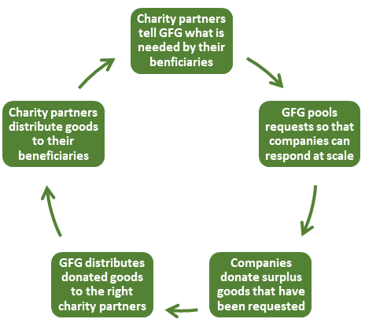We mobilise UK businesses and communities to donate surplus goods - such as clothing, footwear, bedding, toiletries and hygiene products - to improve the lives of vulnerable individuals in need, both in the UK and overseas. Our unique model repurposes unsold goods to provide essential support during crises, making a tangible impact on those we serve. We stand for compassion, sustainability and community support, transforming excess into essential aid for those facing crises.

To date, our resourceful team has sourced and distributed 1.7 million tonnes of essential goods worth £62million to over 5 million people living in 30 countries. This in turn has helped reduce our collective CO2 emissions by 43,515,044 tonnes. That’s the equivalent of taking 9.4 million cars off the road for a year.

**JOB SUMMARY**

The Volunteer Coordinator at Goods For Good plays a pivotal role in making a significant impact on individuals living in challenging circumstances. This role focuses on expanding and nurturing our network of volunteers who are essential in collecting, sorting, packing, and distributing goods. Key responsibilities include:

* Re-engaging with existing volunteers and recruiting new ones.
* Enhancing volunteer management practices to ensure volunteers feel supported and valued.
* Managing corporate packing days, coordinating with companies to involve their employees in our cause.

Once the goods are prepared by volunteers, the Operations team ensures they reach those in need. This position offers a unique opportunity to contribute to a meaningful cause and make a real difference in people's lives.

**KEY RESPONSIBILITIES**

The list of responsibilities given below is a list of “must do” tasks, but there is a huge amount of scope for growth and additional responsibility depending on the successful candidate’s own personal strengths and interests.

1. **Relationship building (25%)**

Support our work to strengthen our volunteer network by:

* Re-engaging with people who already volunteer with us
* Finding new volunteers through networking, publicity and, where possible, public presentations about the work of Goods For Good
* Adding new volunteers to our database via Beacon CRM (training will be provided where this a new CRM to the postholder)

1. **Leading our volunteer management function (15%)**

Review and oversee the processes we have in place to support volunteers by:

* Reviewing and writing job descriptions for identified volunteer roles
* Reviweing and updating our volunteer manual
* Communicating with our volunteers to ensure they remain invested in our work

1. **Overseeing volunteer-led activities (40%)**

Oversee and support our volunteer-led activities by:

* Working with the Operations team to schedule packing events
* Booking volunteers
* Ensuring that volunteers have received training and understand the task
* Attending the activities to oversee their successful execution and to ensure that goods are sorted and packed correctly and volunteers are supported

1. **Collecting evidence to support future volunteer development activities (20%)**

Contribute to the continuation of this work beyond the end of the inital 12 month contract by:

* Documenting the collection events through photos and videos which Goods For Good can share on its social media channels and with its partners
* Recording the number of volunteers that support the events
* Collecting case studies from volunteers about why they choose to work with Goods For Good

**PERSON SPECIFICATION**

**Essential:**

* Personable and welcoming approach to engaging with people
* Strong presentation skills
* Excellent organisational skills
* Event planning and delivery experience
* Skilled with all programmes within Microsoft Office Suite
* Confident with data. Previous experience with a CRM database would be advantageous
* Affinity with Goods For Good’s mission
* Excellent written and spoken English is essential in this role

**Desirable:**

* Experience in the voluntary/community sector in Watford, Hertfordshire and/or North London
* Ability to drive and access to a car would be advantageous in this role

**HOW TO APPLY**

Please submit your CV and cover letter outlining your relevant experience and why you're passionate about joining Goods for Good.

These should be sent to: [judy@goodsforgood.org.uk](mailto:judy@goodsforgood.org.uk).

**Deadline for applications is 24th June 2024 - however candidates will be considered on a rolling basis so the earlier the better.**

*Just as Goods For Good serves everyone around the world regardless of race, ethnicity, gender, religion, sexual orientation or age, we welcome applications from everyone.*